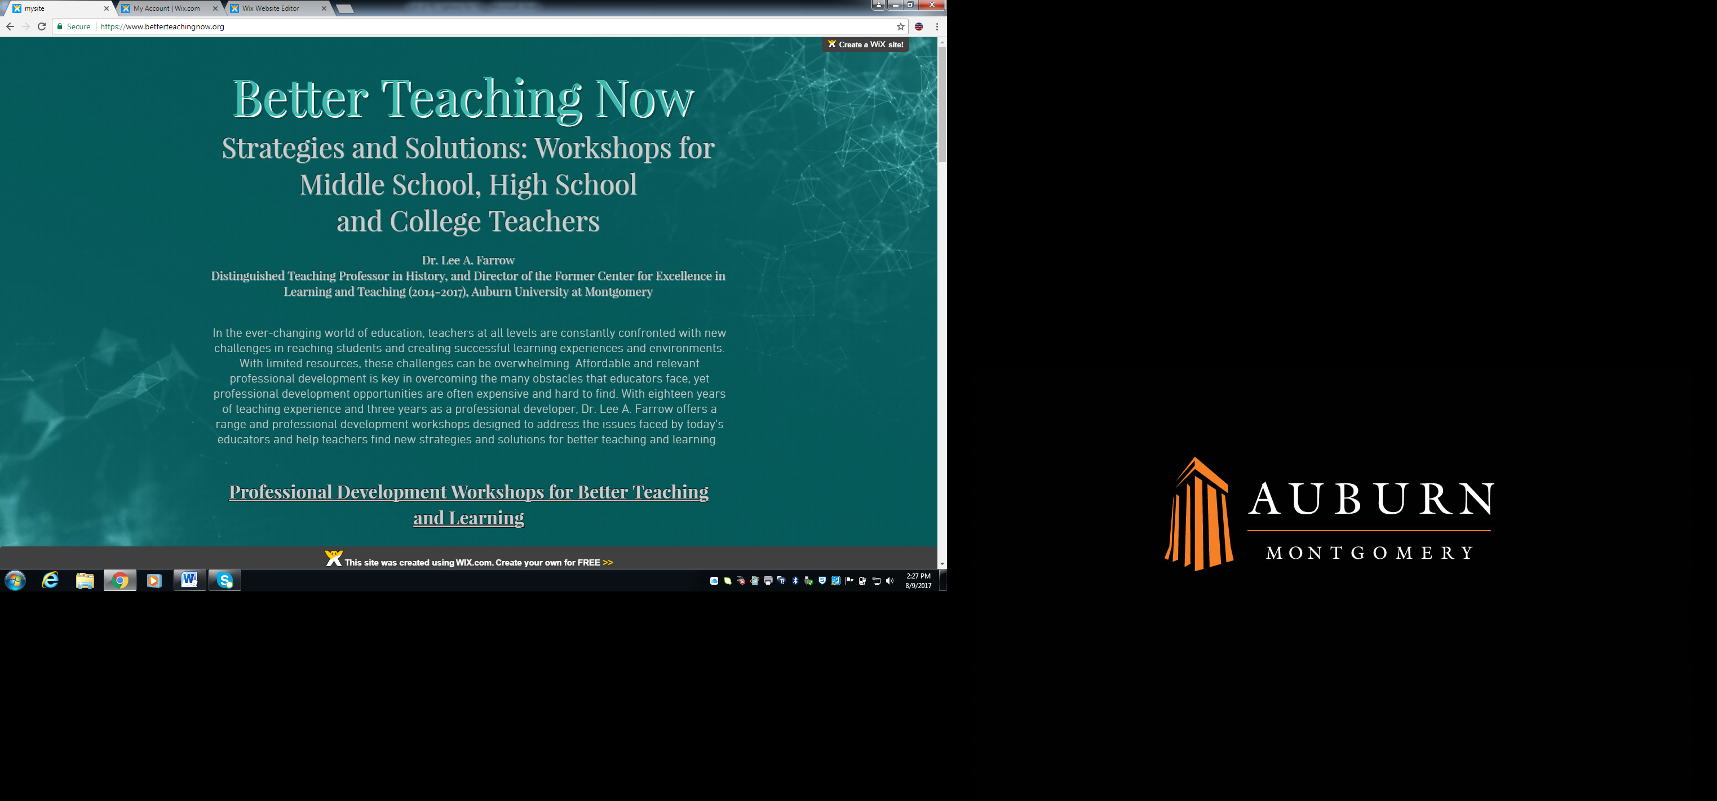

**PROFESSIONAL DEVELOPMENT SESSIONS**

**FOR UNIVERSITY AND COLLEGE EDUCATORS**

**All sessions are 75-90 minutes. $150 per session (plus travel and accommodations where necessary)**

**THE BASICS: PLANNING YOUR COURSES**

**It All Starts with the Syllabus**

A syllabus should be more than just a list of assignments and policies. It also sets the tone for your class, and can be used to motivate students to learn. In this one hour session, we will review and discuss the most effective approaches in creating a syllabus that meets the needs of both faculty and students and creates a positive learning atmosphere. Syllabi that lack clarity (in expectations, in descriptions of assignments, in explanation of class rules) can lead to confusion for students and headaches for instructors.

**Syllabus Swap**

In this session, participants exchange syllabi with their colleagues, read and review them, and then discuss what they have read. Lee Farrow will facilitate the process with a check list of required and recommended elements. Participants will gain insights into the strengths and weaknesses of their own syllabi and get ideas on ways to modify and improve their syllabi. This session pairs well with the session “It All Starts with the Syllabus.”

**Writing a Teaching Philosophy**

A written teaching philosophy is a good way to contemplate and crystalize your thoughts on teaching and why you chose your career, and if often required for annual reviews and tenure and promotion applications. But you might want to consider putting one on your syllabus as well. A teaching philosophy statement communicates to students and colleagues your goals and beliefs about teaching, but it can also inspire students to join you in your passion for your subject matter, resulting in better teacher-student rapport and learning.

**Writing Course Goals and Outcomes for Classes**

While we all know what we hope to accomplish in our classes, we sometimes have trouble putting our ideas into the proper language. Precise and well-designed goals and outcomes, however, are important in clarifying the purpose of each lesson and assignment for ourselves and others, leading to greater buy-in from students and better learning. This session will explain how to write appropriate and achievable goals and outcomes, using the required language of assessment.

The Basics of Backward Design

Most of us designed our first classes on the fly, modeling them after whatever our own professors and advisors had done. Backward design, where the goals are defined first, produces better courses and better learning, however. This session will give a general road map for how to design a better course using backward design. The end result is a class where all assignments and exams are directly connected to learning outcomes and assessment.

**Let’s Get Quizzical**

Studies have shown that regular and repeated quizzing improves student learning and retention more than concentrated blocks of intense studying. In this session, we will discuss ways to incorporate more quizzing into our classes, using creative tools like self-graded online quizzing and group quizzing.

**Great Assignments, Great Expectations**

Feeling stumped for new assignment ideas that are innovative and challenging? Assignments that challenge students to higher levels of thinking but are also fun are a great way to get students excited about your subject and about learning. In this session we will look at a number of creative assignments that ask students to have fun and work hard at the same time

COMMUNICATING WITH AND UNDERSTANDING STUDENTS

**How to Improve Your Student Evaluations**

No, easy grading and pizza is not the answer. But there are a number of things that you can do that can improve how students view you and your class and how they evaluate you at the end of the semester. Research shows that teacher-student rapport is important to students and can affect their willingness to put forth effort and learn. This session will offer suggestions for strategies to achieve higher evaluations while maintaining rigor and high academic standards.

**Stereotype Threat and Student Success**

Research shows that student performance can be affected by stereotypes that are associated with certain groups. For example, women will score lower if reminded of their sex before taking a test. Find out more about this fascinating research and how we as teachers can both battle negative stereotyping in the classroom and present positive contrasting models to encourage students to defy stereotypes.

**Teaching Underprepared Students**

The number of students arriving at college unprepared for college-level work and responsibility is rising across the country, with more students taking remedial classes than ever before. This session will look at ways that individual faculty members can better serve these students who, through no fault of their own, are struggling to succeed in college. We will discuss some easy-to-implement practices that can help us reach these students in the classroom.

Three C’s of Student Motivation and Learning

Wish your students would be more motivated to learn? Bribing students with extra credit and other incentives may get short term results, but does not promote long term enthusiasm and learning. There is no magic bullet, but this session will present information on self-determination theory and some strategies for encouraging intrinsic motivation in your students.

**Self-Efficacy: What It Is, Why It Matters, and How to Incorporate It into Your Classes**

Self-efficacy is one's belief in one's ability to succeed in specific situations or accomplish a task. Studies show that a student’s sense of self-efficacy can play a major role in how he or she approaches goals, tasks, and challenges. Learn how to embed small lessons about self-efficacy into your classes and encourage students to take ownership of their learning and grades.

**IN THE CLASSROOM**

**Priming the Pump: Warm-Ups That Work**

Warm-ups are not ice breakers, but rather a tool for creating better learning. This session will discuss the benefits of using short and easy warm-ups before introducing new chapters, themes, or other bodies of information in your courses. Warm-ups can help you gauge prior knowledge, misconceptions and biases; introduce new terms and concepts; and, generate curiosity and interest in the subject you will be tackling next.

Improving Student Participation In and Out of Class

Participation looks different at different times, for example, during lectures, during discussions, before class, etc. In all cases, however, greater participation means better learning. This session will offer some ideas for getting students to participate more and in more meaningful ways.

**Purposeful Peer Review: A Better Strategy to Promote Better Writing**

Research has shown that student-to-student peer review improves students’ writing and critical thinking skills. Despite these benefits, many teachers shy away from it, unsure that students can do it effectively. This session will present specific and successful strategies to include peer review as part of the writing process and make it helpful for students and teachers.

**Crime and Punishment: Strategies to Prevent Plagiarism and Cheating**

Cheating and plagiarism are serious problems in colleges across the nation. This session will feature a discussion of why students cheat, strategies to prevent various types of cheating, and how to handle cheating. In addition, teachers will receive an in-depth explanation of plagiarism and how to teach students what it is and how to avoid it.

Cell Phones, Tardiness, and Absenteeism: Strategies for Handling Problematic Student Behavior

Students test our patience with behavior that interferes with our ability to teach and their ability to learn. In this session, we will discuss different strategies for combatting these behaviors, as well as explore creative ways to frame the problem for less frustration and better outcomes.

**Thinking about How We Think: Metacognition and Our Students**

Metacognition explores how a heightened awareness of the ways we think about and learn information can help us to enhance our students’ learning.  This session will present ways to more effectively assess the levels of learning among our students and discuss how we can help student understand, and strive toward, these higher levels of learning.

**Experiential Learning: Explanations and Examples**

Experiential learning is a phrase that means different things to different people and encompasses a wide variety of activities designed to encourage students to intentionally utilize both knowledge and skills in “real-world” situations. In this session, we will discuss the various forms experiential learning can take, and begin a dialogue about how teachers might incorporate it.

Fruitful Feedback: Same Effort, More Impact

The time we dedicate to feedback is pointless if students don’t read it (hear it) and if it doesn’t help them improve their performance. For students to benefit from feedback, it must be given early and often, and it must be clear, constructive, and useful. In this session, we will discuss the difference between auditive feedback and educative feedback, and present some concrete examples of better feedback.

**Grappling with Grading: Late Work, Extra Credit, and Other Grading Issues**

It is safe to say that grading is one of the toughest parts of teaching, and we are constantly confronted with a host of issues and student requests that make it even more difficult. In this session, we will discuss these challenges and offer some solutions, while also reconsidering our own notions about the purpose of grades.

**Are Grades the Same as Assessment?: Well, Sometimes …**

Carnegie Mellon’s Eberly Center site for Teaching Excellence & Educational Innovation states that “the goal of grading is to evaluate individual students’ learning and performance…the goal of assessment is to improve student learning.” Still, many of us struggle to see or appreciate the difference, a result of how we were trained or possibly a culture of grading. In this session, we will discuss the difference between grading and assessment, how the two can intersect, and how to make your grades a more accurate reflection of student learning.

**Will This be on the Test? The Pros and Cons of Study Guides**

Students beg for study guides, but should we give them? What kind should we give, if any? Do study guides help students, or are they crutches that encourage lazy studying and learning strategies? In this session, we will discuss the research on learning as it relates to study guides and examine some best practices for creating study guides that promote learning not just rote memorization.

**Professionalism in the Classroom**

Striking the proper tone in the classroom can be difficult. We want to be liked and approachable but also respected. At the same time, we have to be professional – in our language, our behavior, and even our dress. In this session, we will discuss how to balance all these demands.

**OUTSIDE OF CLASS**

**Making the Most of Office Hours**

The students who need us the most will discuss how to use mandatory one-on-one conferencing to enhance student learning. Topics covered may include using conferences to address student misunderstandings, to workshop assignments, and to develop mentoring relationships.

**EVALUATING OURSELVES**

**Teaching Square Program**

A Teaching Square is an arrangement in which four faculty members agree to visit each other’s classes over the course of a semester and then meet to discuss what they have learned from their observations. By allowing faculty to be “learners” again in their colleagues’ classes, the Square provides faculty with an opportunity to gain new insight into their own teaching through a *non-evaluative* process of reciprocal classroom observation and self-reflection. In this session we will explain the process, divide faculty into groups of four, and help them get started.

**TWO-DAYWORKSHOPS - $1600 for a total of 12 hours of professional development**

**Course Design Workshop**

The goal of this workshop is to help faculty begin the process of designing a new course by providing a designated time and a group of resources for that purpose. The workshop will include coffee, snacks, and lunch for two days, as well as a variety of useful materials and resources. The presentations and topics covered during the two-day workshop will include syllabus design, writing course goals and outcomes, metacognition, incorporating technology, and writing effective assignments and exams. Several sessions will be dedicated to peer review of participants’ course design drafts.

**Course Redesign Workshop**

The goal of this workshop is to help faculty begin the process of redesigning a previously-taught course by providing a designated time and a group of resources for that purpose. The workshop will include coffee, snacks, and lunch for two days, as well as a variety of useful materials and resources. The presentations and topics covered during the two-day workshop will include syllabus design, writing course goals and outcomes, metacognition, incorporating technology, and writing effective assignments and exams. Several sessions will be dedicated to peer review of participants’ course design drafts. Participants for this workshop will be selected in two ways: 1) by recommendation of a department head or dean; 2) on a first come/first served basis. This workshop will be limited to 12 people.

**Contact Information:**

Dr. Lee A. Farrow

Department of History, World Languages and Cultures

Auburn University at Montgomery

[lfarrow@aum.edu](mailto:lfarrow@aum.edu)

Cell Phone: 334-546-5631

Website: [www.betterteachingnow.org](http://www.betterteachingnow.org)