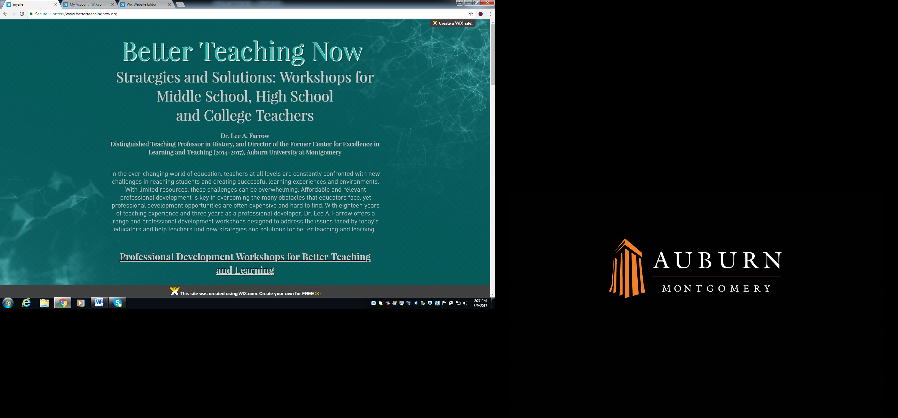

**PROFESSIONAL DEVELOPMENT SESSIONS**

**All sessions are 75-90 minutes. $150 per session, plus travel/hotel (if needed)**

**THE BASICS: PLANNING YOUR COURSES**

**It All Starts with the Syllabus**

A syllabus should be more than just a list of assignments and policies. It also sets the tone for your class, and can be used to motivate students to learn. In this session, we will review and discuss the most effective approaches in creating a syllabus that meets the needs of both faculty and students and creates a positive learning atmosphere. Syllabi that lack clarity (in expectations, in descriptions of assignments, in explanation of class rules) can lead to confusion for students and headaches for instructors. Finally, as educators, it is important to recognize that your syllabi and the way you use your syllabi can help better prepare your students for the expectations of college.

**Syllabus Swap**

In this session, participants exchange syllabi with their colleagues, read and review them, and then discuss what they have read. Lee Farrow will facilitate the process with a check list of required and recommended elements. Participants will gain insights into the strengths and weaknesses of their own syllabi and get ideas on ways to modify and improve their syllabi. This session pairs well with the session “It All Starts with the Syllabus.”

**Writing a Teaching Philosophy**

A written teaching philosophy is a good way to contemplate and crystalize your thoughts on teaching and why you chose your career, and can be a reminder of those reasons on tough teaching days. But you might want to consider putting one on your syllabus as well. A teaching philosophy statement communicates to parents, students, and colleagues your goals and beliefs about teaching, but it can also inspire students to join you in your passion for your subject matter, resulting in better teacher-student rapport and learning.

**Writing Measurable Goals and Outcomes for Content Standards**

While we all know what we hope to accomplish in our classes, we sometimes have trouble putting our ideas into the proper language. Precise and well-designed goals and outcomes, however, are important in clarifying the purpose of each lesson and assignment for ourselves and others, leading to greater buy-in from students and parents and better learning. This session will explain how to write appropriate and achievable goals and outcomes, using the required language of assessment.

The Basics of Backward Design

Backward design, where the measurable goals are defined first, produces better courses and better learning. This session will give a general road map for how to design a better course using backward design. The end result is a class where all assignments and exams are directly connected to learning outcomes and assessment.

Designing Effective Rubrics for Better Communication and Learning

Many of us were introduced to the notion of rubrics late in our teaching careers; some of us still resist them. But rubrics can make grading easier, quicker, and fairer, while also creating greater transparency and understanding for students. This session will discuss the benefits of rubrics, for you and your students.

**Quizzing for Improved Learning, Especially with Struggling and Low-Performing Students**

Studies have shown that regular and repeated quizzing improves student learning and retention more than concentrated blocks of intense studying. In this session, we will discuss ways to incorporate more quizzing into our classes, using creative tools like self-graded online quizzing and group quizzing.

**Great Assignments, Great Expectations – Fun and Creative Ways of Challenging Students**

Feeling stumped for new assignment ideas that are innovative and challenging? Assignments that challenge students to higher levels of thinking but are also fun are a great way to get students excited about your subject and about learning. In this session we will look at a number of creative assignments that ask students to have fun and work hard at the same time.

COMMUNICATING WITH AND UNDERSTANDING STUDENTS

**How to Improve Classroom Culture and Climate and Create Better Learning**

No, easy grading and pizza is not the answer. But there are a number of things that you can do that can improve interactions with students and how they view you and your class. Research shows that teacher-student rapport is important to students and can affect their willingness to put forth effort and learn. This session will suggest strategies to achieve better teacher-student rapport while maintaining rigor and high academic standards.

**Stereotype Threat and Student Success for At-Risk and Struggling Students**

Research shows that student performance can be affected by stereotypes that are associated with certain groups. For example, women will score lower if reminded of their sex before taking a test. Find out more about this fascinating research and how we as teachers can both battle negative stereotyping in the classroom and present positive contrasting models to encourage students to defy stereotypes.

**Keys to Teaching Underprepared and Low-Performing Students**

The number of students performing below grade level is rising across the country, with more students taking than ever before. This session will look at ways that teachers can better serve these students who are struggling to succeed, including some easy-to-implement practices that can help us reach these students in the classroom.

Three C’s of Student Motivation and Learning

Wish your students would be more motivated to learn? Bribing students with extra credit and other incentives may get short term results, but does not promote long term enthusiasm and learning. There is no magic bullet, but this session will present information on self-determination theory and some strategies for encouraging intrinsic motivation in your students.

**Self-Efficacy: What It Is, Why It Matters, and How to Incorporate It into Your Classes**

Self-efficacy is one's belief in one's ability to succeed in specific situations or accomplish a task. Studies show that a student’s sense of self-efficacy can play a major role in how he or she approaches goals, tasks, and challenges. Learn how to embed small lessons about self-efficacy into your classes and encourage students to take ownership of their learning and grades.

**IN THE CLASSROOM**

**Priming the Pump: Warm-Ups That Work**

Warm-ups are not ice breakers, but rather a tool for creating better learning. This session will discuss the benefits of using short and easy warm-ups before introducing new chapters, themes, or other bodies of information in your courses. Warm-ups can help you gauge prior knowledge, misconceptions and biases; introduce new terms and concepts; and, generate curiosity and interest in the subject you will be tackling next.

Improving Student Participation In and Out of Class

Participation looks different at different times, for example, during lectures, during discussions, before class, etc. In all cases, however, greater participation means better learning. This session will offer some ideas for getting students to participate more and in more meaningful ways.

**Purposeful Peer Review: Promoting Better Writing for College and Career Readiness**

Research has shown that student-to-student peer review improves students’ writing and critical thinking skills. Moreover, peer review is often used at the college level, so getting students accustomed to the practice will help them appreciate it more when they encounter it later in their education. Despite these benefits, many teachers shy away from it, unsure that students can do it effectively. This session will present specific and successful strategies to include peer review as part of the writing process and make it helpful for students and teachers.

**Crime and Punishment: Strategies to Prevent Plagiarism and Cheating**

Cheating and plagiarism are serious problems in high schools and colleges across the nation. This session will feature a discussion of why students cheat, strategies to prevent various types of cheating, and how to handle cheating. In addition, teachers will receive an in-depth explanation of plagiarism and how to teach students what it is and how to avoid it.

Reframing Classroom Discipline Issues: Strategies for Handling Problematic Student Behavior

Students test our patience with behavior that interferes with our ability to teach and their ability to learn. In this session, we will discuss different strategies for combatting these behaviors, as well as explore creative ways to frame the problem for less frustration and better outcomes.

**Thinking about How We Think: Metacognition and Improving Student Performance**

Metacognition explores how a heightened awareness of the ways we think about and learn information can help us to enhance our students’ learning.  This session will present ways to more effectively assess the levels of learning among our students and discuss how we can help student understand, and strive toward, these higher levels of learning.

**Experiential Learning: Explanations and Examples**

Experiential learning is a phrase that means different things to different people and encompasses a wide variety of activities designed to encourage students to intentionally utilize both knowledge and skills in “real-world” situations. In this session, we will discuss the various forms experiential learning can take, and begin a dialogue about how teachers might incorporate it.

Fruitful Feedback: A Critical Component for Success with Low-Performing Students

The time we dedicate to feedback is pointless if students don’t read it (hear it) and if it doesn’t help them improve their performance. For students to benefit from feedback, it must be given early and often, and it must be clear, constructive, and useful. In this session, we will discuss the difference between auditive feedback and educative feedback, and present some concrete examples of better feedback.

**Grappling with Grading: Late Work, Extra Credit, and Other Grading Issues**

It is safe to say that grading is one of the toughest parts of teaching, and we are constantly confronted with a host of issues that make it even more difficult. In this session, we will discuss these challenges and offer some solutions, while also reconsidering our own notions about the purpose of grades.

**Are Grades the Same as Assessment?: Well, Sometimes …**

Carnegie Mellon’s Eberly Center site for Teaching Excellence & Educational Innovation states that “the goal of grading is to evaluate individual students’ learning and performance…the goal of assessment is to improve student learning.” Still, many of us struggle to see or appreciate the difference, a result of how we were trained or possibly a culture of grading. In this session, we will discuss the difference between grading and assessment, how the two can intersect, and how to make your grades a more accurate reflection of student learning.

Teaching Research Skills for College and Career Readiness

Whether students decide to go to college or begin a career, they will certainly be expected to utilize research and critical thinking skills. In this session we will discuss how to teach research skills and how to design an effective research project that guides students through the process of locating and utilizing reliable information, communicating clearly, and properly citing sources.

**Will This be on the Test? The Pros and Cons of Study Guides**

Students beg for study guides, but should we give them? What kind should we give, if any? Do study guides help students, or are they crutches that encourage lazy studying and learning strategies? In this session, we will discuss the research on learning as it relates to study guides and examine some best practices for creating study guides that promote learning not just rote memorization.

**Professionalism in the Classroom**

Striking the proper tone in the classroom can be difficult. We want to be liked and approachable but also respected. At the same time, we have to be professional – in our language, our behavior, and even our dress. In this session, we will discuss how to balance all these demands.

**Unskilled and Unaware: Students Usually Don’t Know What They Don’t Know**

Research shows that students are often terrible at predicting whether they are prepared for exams and have exercised effective study skills. Students do not know they are unskilled until we teach them the skills they need to reach their learning targets.  In this session, we will identify ways to help students recognize what they do not know and what feedback we can provide to help them become skilled at studying and learning.

**Contact Information:**

Dr. Lee A. Farrow

3352 Le Bron Rd

Montgomery AL 36106

[lfarrow@aum.edu](mailto:lfarrow@aum.edu)

Cell Phone: 334-546-5631

Website: [www.betterteachingnow.org](http://www.betterteachingnow.org)

**Endorsements for Dr. Lee A. Farrow’s Professional Development**

“Dr. Farrow is a conscientious professor who knows how to connect with her students both intellectually and emotionally. She is always innovating in the classroom, striving to develop and improve upon techniques for helping her students engage with the material. The professional development she has provided to her colleagues has been invaluable.” – Dr. Rolando Carol, Assistant Professor of Psychology, AUM

"Dr. Lee Farrow did a magnificent job running the Center for Excellence in Learning and Teaching (CELT) program at AUM. Dr. Farrow provided a wide variety of presentations on pedagogy, from how to lead discussions effectively, to creating better syllabi and teaching statements, to classroom management. ...  I know that I am a better and a more creative teacher thanks to Lee Farrow and her excellent work with the CELT program." - Dr. Eric Sterling, Professor, Department of English and Philosophy, AUM

"Lee Farrow brings a refreshing breath of air to professional development sessions. Her ability to choose topics of discussion that engage participants likely derives from her years as an excellent teacher, lauded by administration, colleagues, and students alike."  -- Susan Barganier, Former Director of the AUM Learning Center

"Dr. Farrow is an electrifying public speaker.  Her passion for the subject matter is infectious.  In each session, attendees gain fresh perspective on major trends within higher education and transforming the classroom using innovation and creativity." -- Dr. Jason Gouge, Department of Business Administration, AUM

​

“In my opinion, the characteristics of a great presenter/educator include being a professional who is not only an expert in their respective field of study with a deep knowledge base, but also someone who can get their points across to a diverse audience in different ways if needed.  One has to not only possess the knowledge, one has to be a very effective communicator as well and Dr. Farrow has these characteristics.” -- Dr. Glen Ray, Chair, Department of Psychology, AUM

​

“Dr. Farrow is one of the most knowledgeable and personable teachers that I have had the pleasure of working with over the past several years.  Not only are her presentations informative and easy to follow, but her ethics and character are apparent in everything she sets out to accomplish.  ... I have certainly become a much more confident and effective teacher due to Dr. Farrow’s incredible work and examples of strong leadership.” -- Sissy Speirs, Bridge Program Manager, AUM

“Attending Dr. Farrow's professional development sessions on course and syllabus design, the benefits of warm-up activities and quizzing, self-efficacy in the classroom, and giving productive feedback to students have transformed my courses and teaching style. As a result, my students are more engaged and in addition to learning the content in deeper ways they are learning to be better learners. Dr. Farrow provides immediately usable tips and strategies. And she will get you excited about trying new teaching tactics!” – Dana Bice, Adjunct in the Department of Fine Arts and Former Program Manager of the Writing Across the Curriculum Program, AUM